User Manual
Asset Management System

User Registration
- First open Any browser (Suggested Edge, Chrome).
- Access the site IP http://200.2.4.52:9669
- Click the Create account (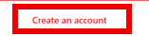) Button under the Log in button.

(Fig. 1)
- Now fill up all the required fields in the registration form see Fig. 2 for reference.

(Fig. 2)
- After filling up all the fields in the registration form click the Create account
() see Fig.2 for reference.
- Check your Email address and look for an email from it.github@theblackcoders.com that contains your verification code.
- Enter your verification code in the Verify Email fields see Fig. 3.
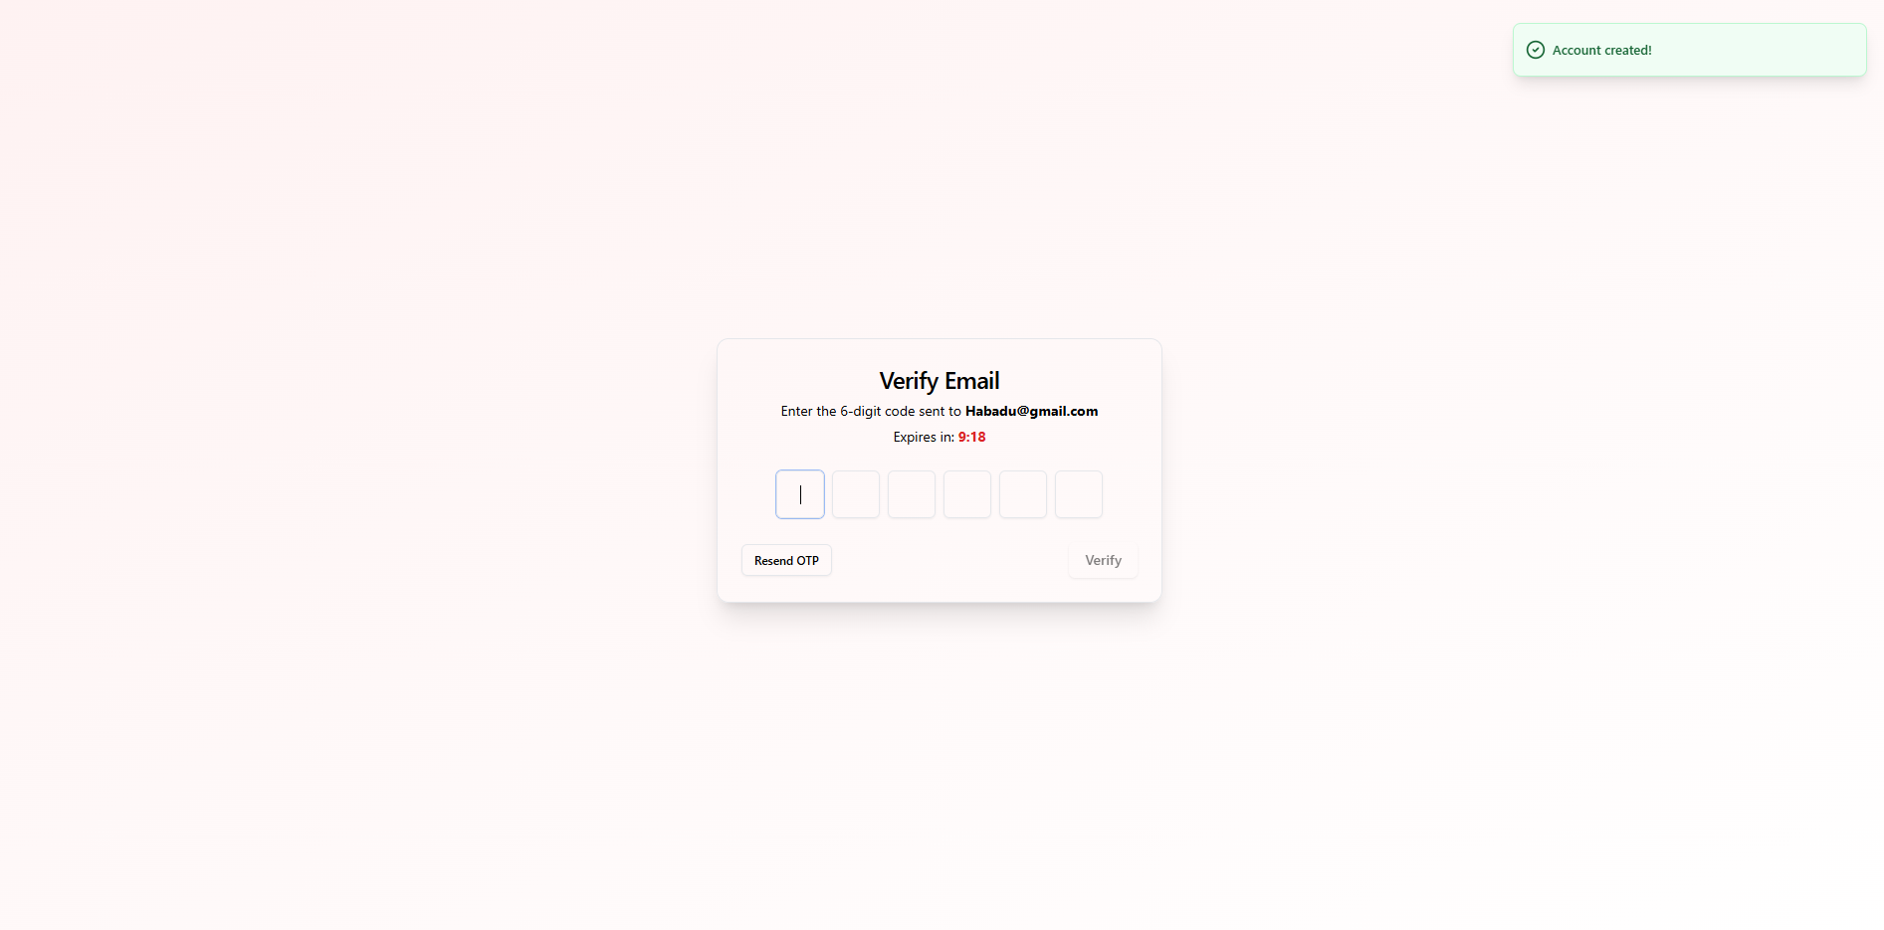
(Fig. 3)
  - If you don’t see any email from the it.github@theblackcoders.com click the resend OTP in the verify email page see Fig 3.1.

(Fig. 3.1)
  - Enter the received OTP at the verify email field and Click the Verify Butto see Fig. 3.2

(Fig. 3.2)
- Click the Verify button after entering the OTP in the fields see Fig. 3.2.

Log In

- Enter Email and password in the Login forms see Fig. 4.
(Fig. 4)
- Click Login after entering Email and password see Fig. 5.

(Fig. 5)

Forgot password

- Click the forgot password? in the Log in page under the password field.

(Fig. 6)
- Enter your email.
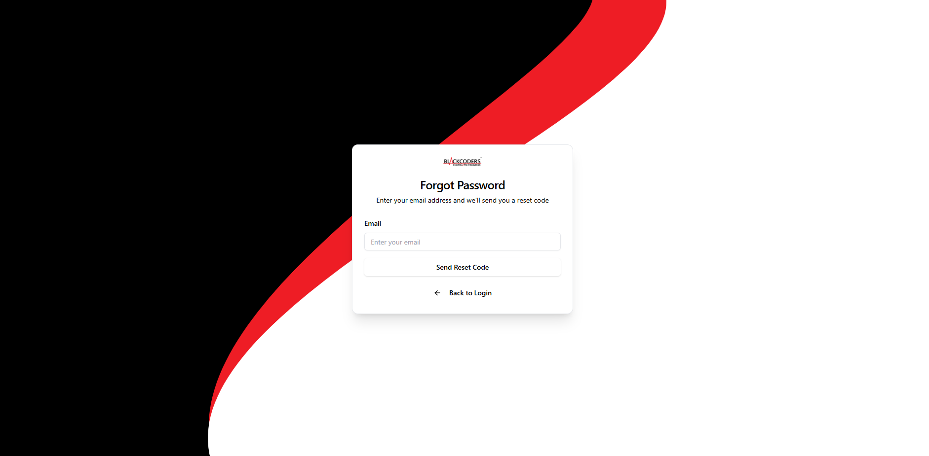
(Fig. 7)
- Click the Send Reset Code button.

(Fig. 8)

- Check your email and look for email from the it.github@theblackcoders.com and copy the OTP and paste it in the OTP Field see Fig. 9.
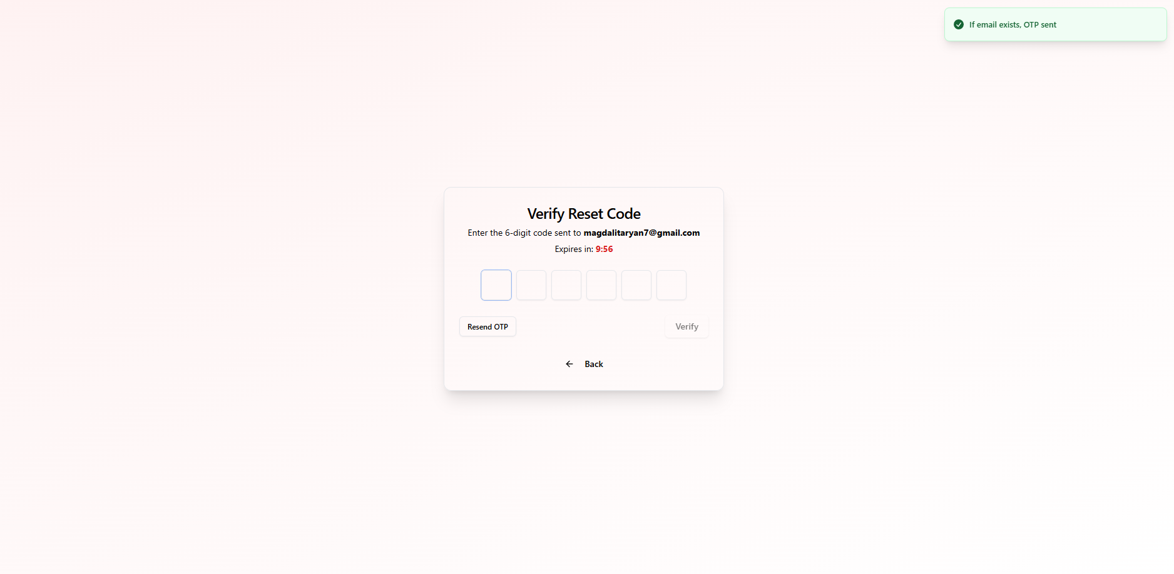
(Fig. 9)
  - If there is no email click the Resend OTP button see Fig. 9.1.

(Fig. 9.1)
- Click the Verify button after entering the OTP see Fig. 9.2.

(Fig. 9.2)

Admin Dashboard
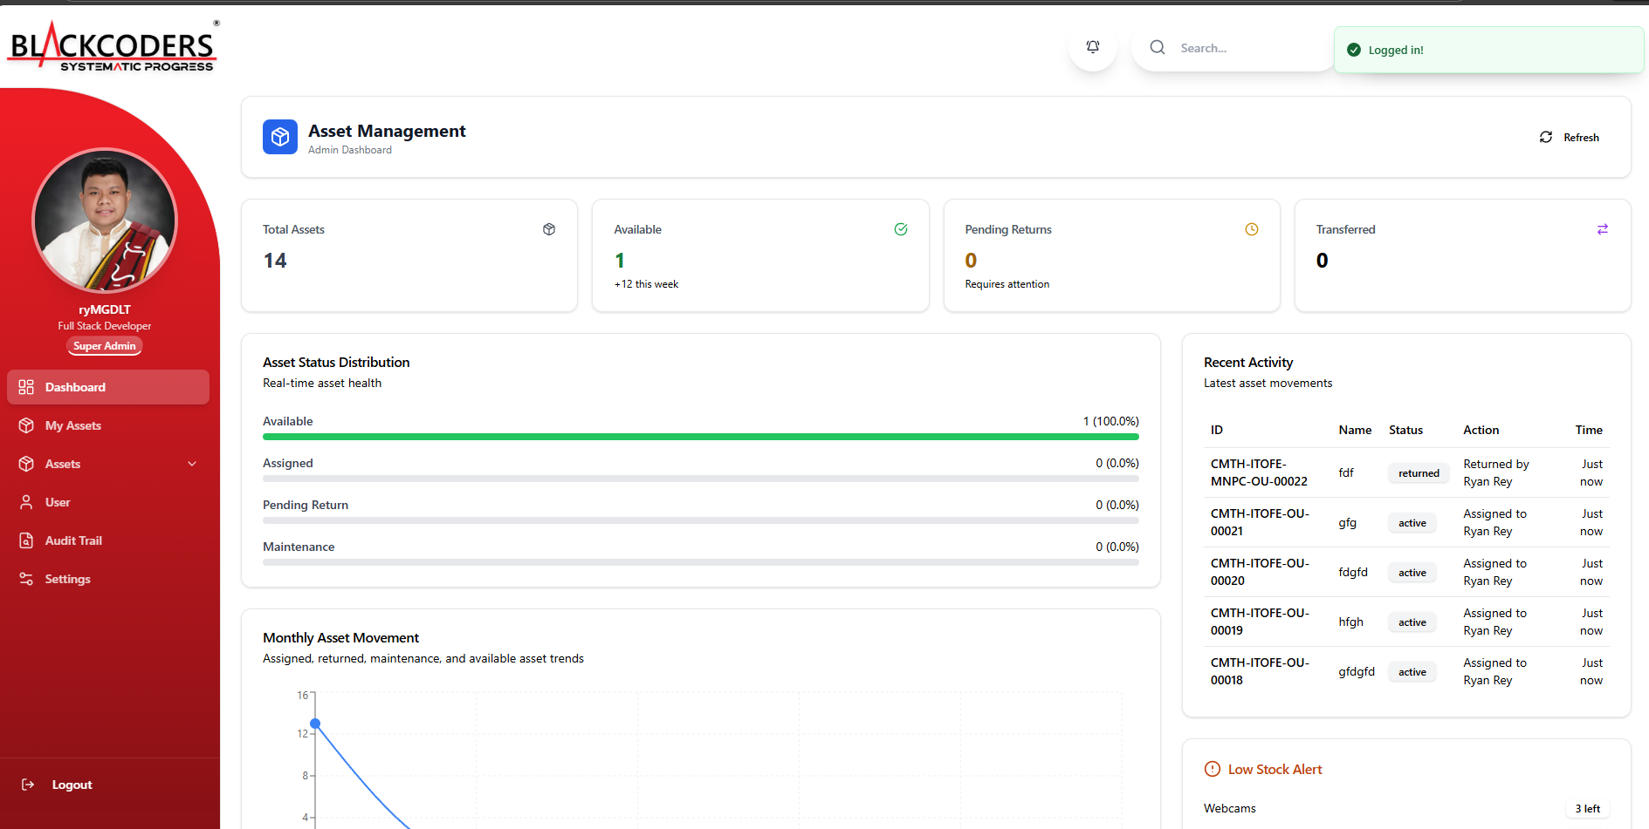
(Fig. 10)

My Asset List

- In the sidebar Click My asset.
